Visiting the Reindeer Farm

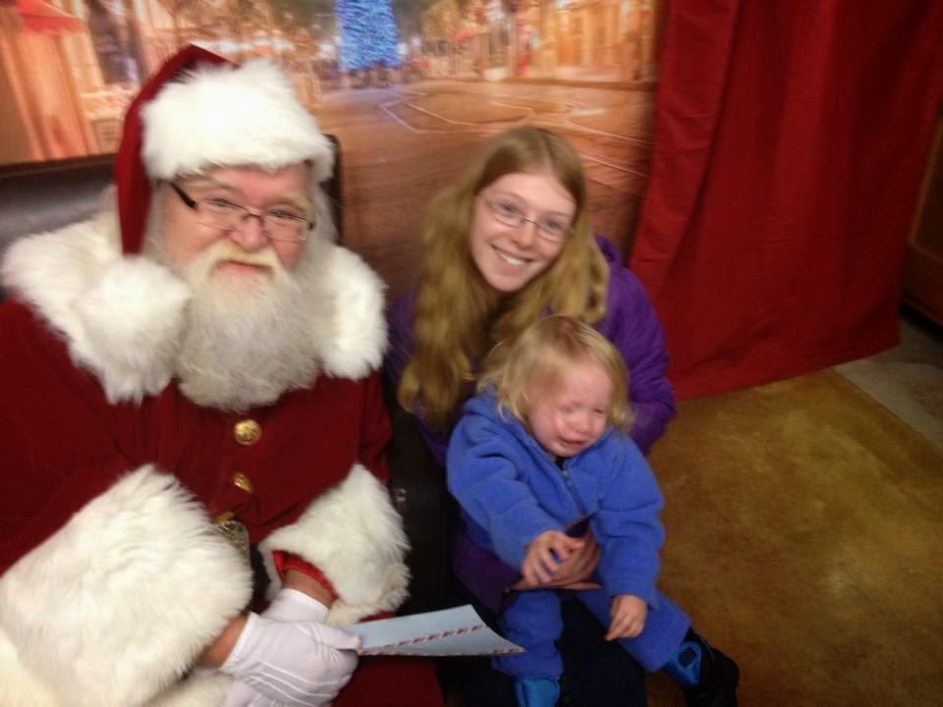

Late last month, a trip to a farm where the kids would be able to see actual reindeer, visit Santa Claus, and get their pictures taken with *Frozen* characters seemed almost obligatory. It was the weekend after Thanksgiving, and since we didn’t travel to visit anybody it seemed like we really ought to go somewhere.

That’s when I heard about the Rooftop Landing Reindeer farm just south of Clare. They were holding an event where the kids could hang out with animals, meet Santa Claus, etc. Some friends of ours were going, and had actually invited Kayla. I said something about going to, because I knew Elijah would get a kick out of seeing animals, and I was itching for a chance to get a photo of him sitting on Santa’s lap. Actually, my biggest motivation was to see Elijah react. Josh and Kayla might get a kick out of it, but as they are getting older they are harder to impress.

So, we piled into my car and headed north towards Rosebush. One thing that always amazes me is the amount of gear I usually need just to take a day trip. One primary diaper bag, and then another as backup. Blankets, pacifier, backup pacifier, spare backup pacifier...okay, okay, a lot of pacifiers. Never want to be caught without a pacifier. Sippy and snacks. Stroller in the trunk, and then my bag with iPad, digital camera, and charger for my phone.

By the time we arrived at the farm, their parking lot was so full that people were already parking on their yard. Or field. Or, you might have even called it a swamp or marsh land, because the ground was pretty soggy. There were other cars getting stuck while they were maneuvering around, and I wasn’t too sure I would make it out. But, I found a parking space that seemed dry. As I got out, water was squishing out of the ground each time I took a step. And, I was the only one who hadn’t worn boots.

We made our way to “Santa’s Workshop,” where all of the action would be. After paying the admission fee, we began to wander around. There were a lot of people there, so it wasn’t so easy to navigate, especially with a toddler in tow. We checked out the animals first. Elijah called the reindeer a “cow.” I think that the reindeer was his favorite, though, because he kept going back to it.

Santa was taking requests and towards the back there was an area set up where people could pay to have their pictures taken sitting on a real sleigh next to cardboard pictures of characters from *Frozen*. Snore. And, here I thought there would be costumed characters. As the line for Santa wasn’t that long, I jumped in with Elijah, and soon it was his turn. He didn’t like it at all when I sat him down on Santa’s lap, and he was pretty upset when Kayla took him and sat down with him. Still, I got the photo I sort of wanted.

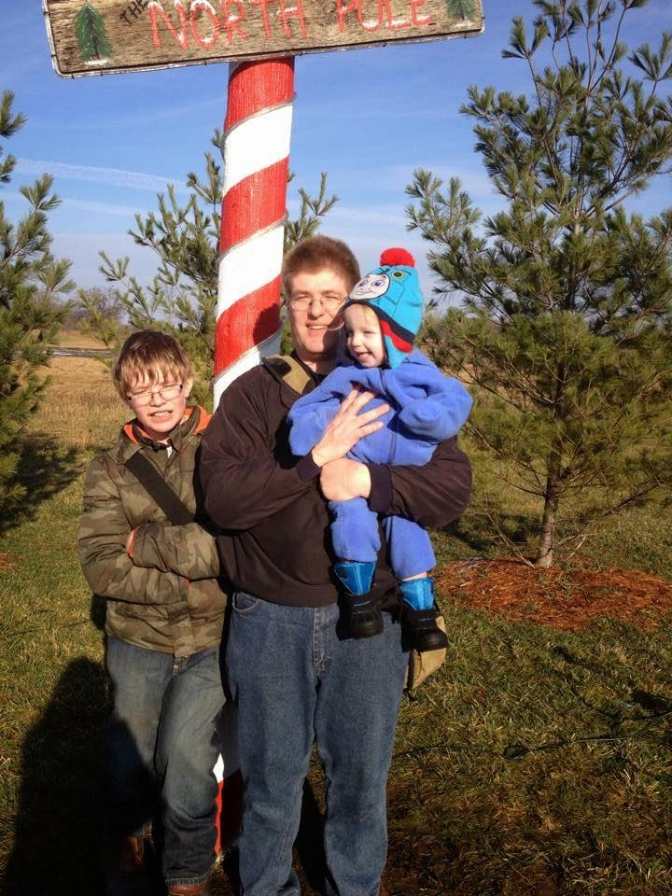

Once we had seen the animals, seen Santa, and gotten some other photos, we realized that we had actually done everything we could and started for home. On our way to the car, we watched a minivan being towed out of a very muddy portion of the front lawn by a pickup truck. I suddenly wasn’t sure how we would be able to get back onto the road, but then again my car is lighter than the average minivan. After we loaded into the car, I pulled around and just kept creeping along until I reached some more solid ground.

On our way through Mount Pleasant, we stopped at the library there. Elijah “helped” me pick out movies to rent, while the kids spent some time on the computers on the first floor. Of course, Elijah’s way of helping was to grab random movies off the shelf so that I would have to take them from him and then figure out where they go. Or, after I set him down, chasing after him and then bringing him back to the aisle with the videos so I could finish making my selection.

All in all, it was a good visit.

# Photo Gallery

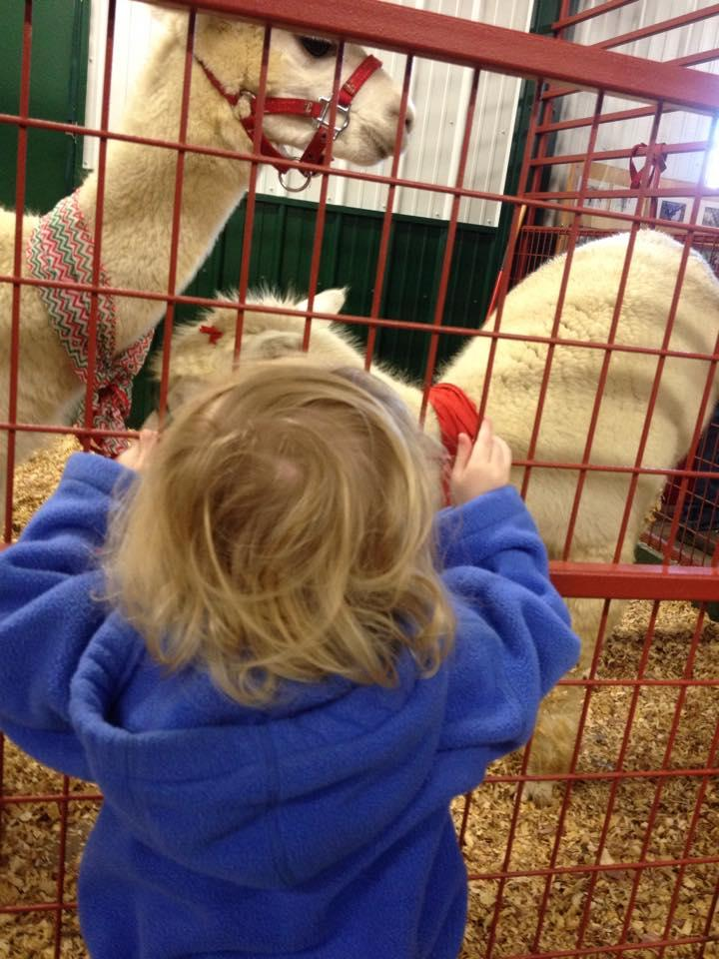

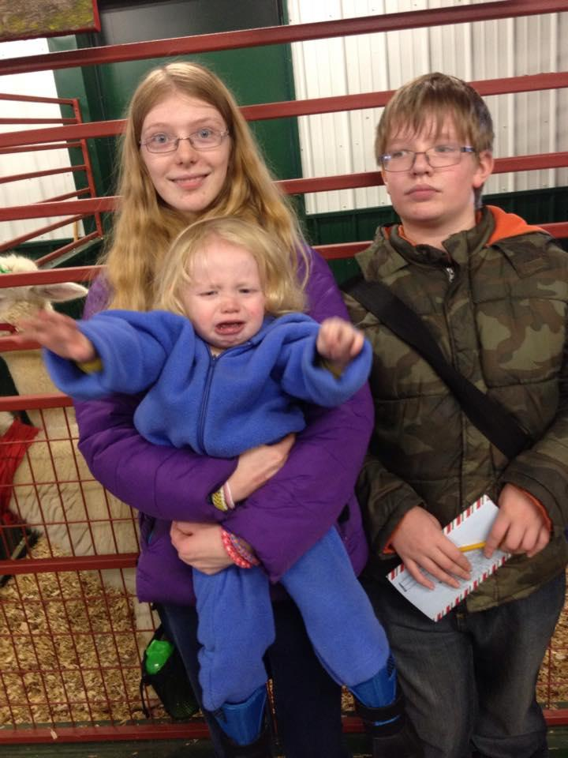

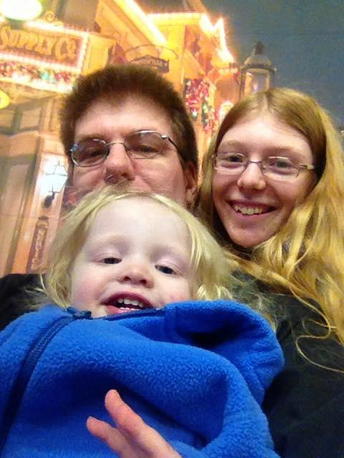

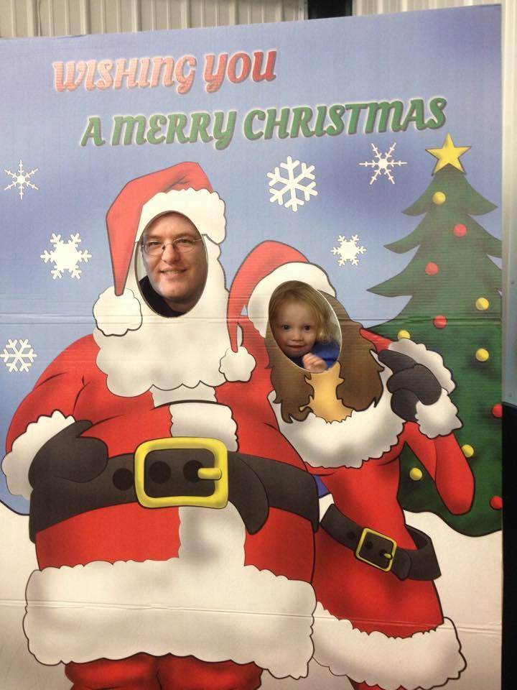

[View Online](https://medium.com/@morga2ja/visiting-the-reindeer-farm-62aeacfc0592) / [Suggest Edits](https://quip.com/yVX9At2ElkhT) / [Comment](https://docs.google.com/document/d/1XQznxrV3lsDz27bq1_EoInaQk15CU7QFPsdu2dvmAwU/edit?usp=sharing) / [Share Your Story](https://medium.com/p/62aeacfc0592/responses/new) / [Send Email](mailto:cyberlandhq@gmail.com)